ANNEXURE L: HAUWENG PHASE 1 CORRIDOR SYSTEM

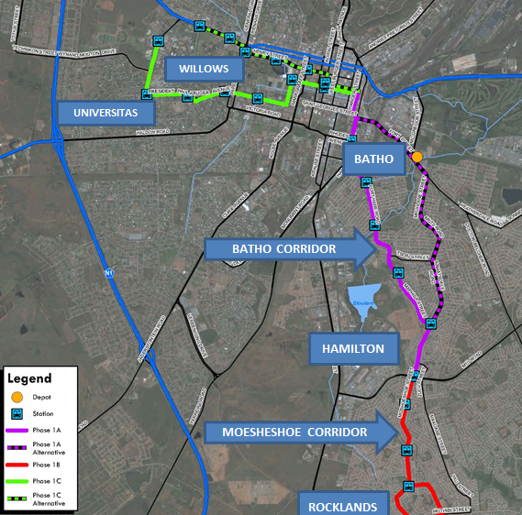

Corridor | Key Issues | Proposed solutions
Moshoesoe corridor | - Infrastructure constructed in 2004 - Upgrades are required  - No Universal Access designs at intersections  - Pedestrian linkages to Moshoeshoe road in poor condition (gravel roads)  - No dedicated cycle lanes available, though there is cyclist demand | - Universal access upgrades  - Raised pedestrian crossings  - Way finding signage and  - Urban design pedestrian elements e.g. street furniture, where required  - The proper maintenance and development of the public space is a key element towards township regeneration
Batho Heritage corridor | - No NMT Infrastructure along Batho Corridor  - High mobility road - unsafe for crossing  - Traffic Signals not accommodating pedestrian phases  - No shelters at public transport stops  - No dedicated cycle lanes along route, though there is heavy cyclist demand

